**Website planning**

**Personal website info:**

What should your website do

* What is your website about: a Q and A platform for clients to ask me their idea related questions
* Title : #AskTheIdeaDeveloper
* Paragraph: Have you got an idea you would love to build, why not ask me your idea related questions to help you get started.

Remember no idea is silly or simple; it just needs the right person to listen and help you plan. So let’s have some fun ideating.

* Image:

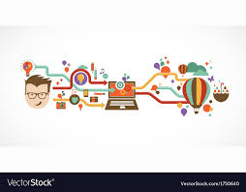

* Background color: white
* Background font: cartoony, fun and like a private pop up sessions filled with notifications like chat messages.

**Design sketch**

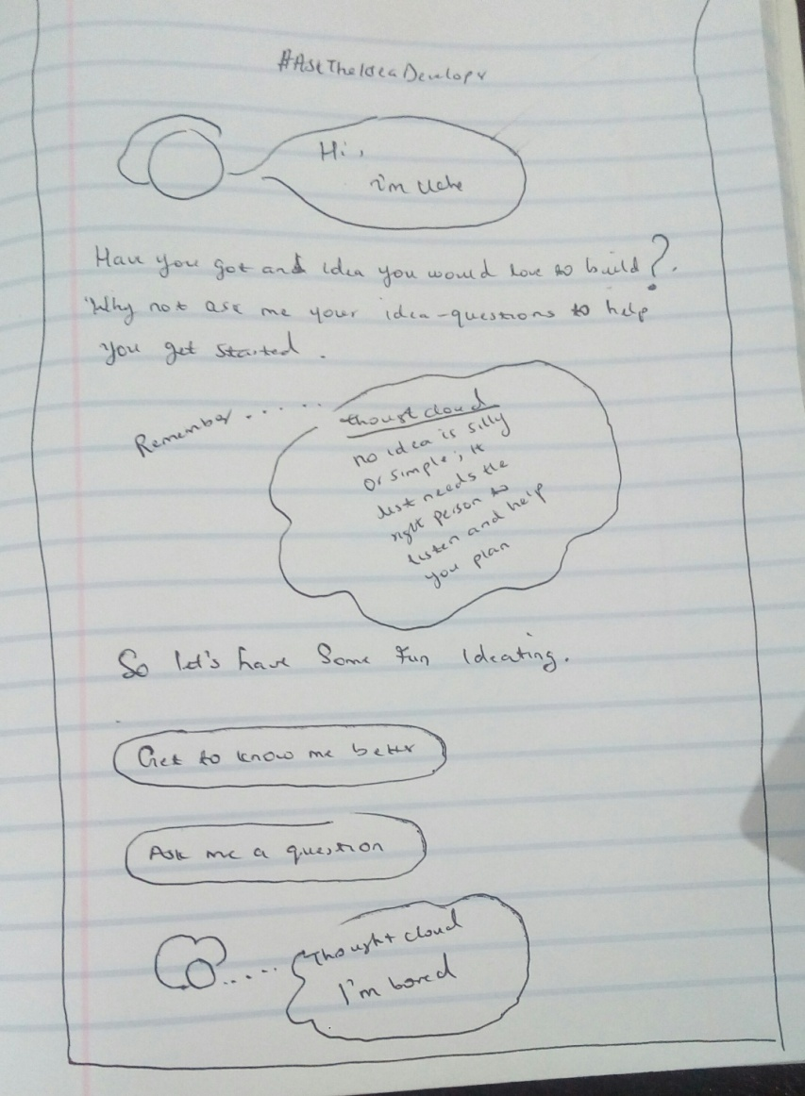

**Assets**

Text:

#AskTheIdeaDeveloper

Have you got an idea you would love to build, why not ask me your idea related questions to help you get started.

Remember no idea is silly or simple; it just needs the right person to listen and help you plan. So let’s have some fun ideating.

Theme colors

* **Green** rgb(58, 186, 122)/ #3ABA7A
* **Orange** rgb(240, 71, 29)/ #fa7e02
* **Fusia/red** rgb(235, 29, 60)/ #EB1D3C
* **Blue** rgb(54, 81, 236)/ #3651EC
* **Grey** #f7f8fa
* **Yellow** #e1fa02

Image:

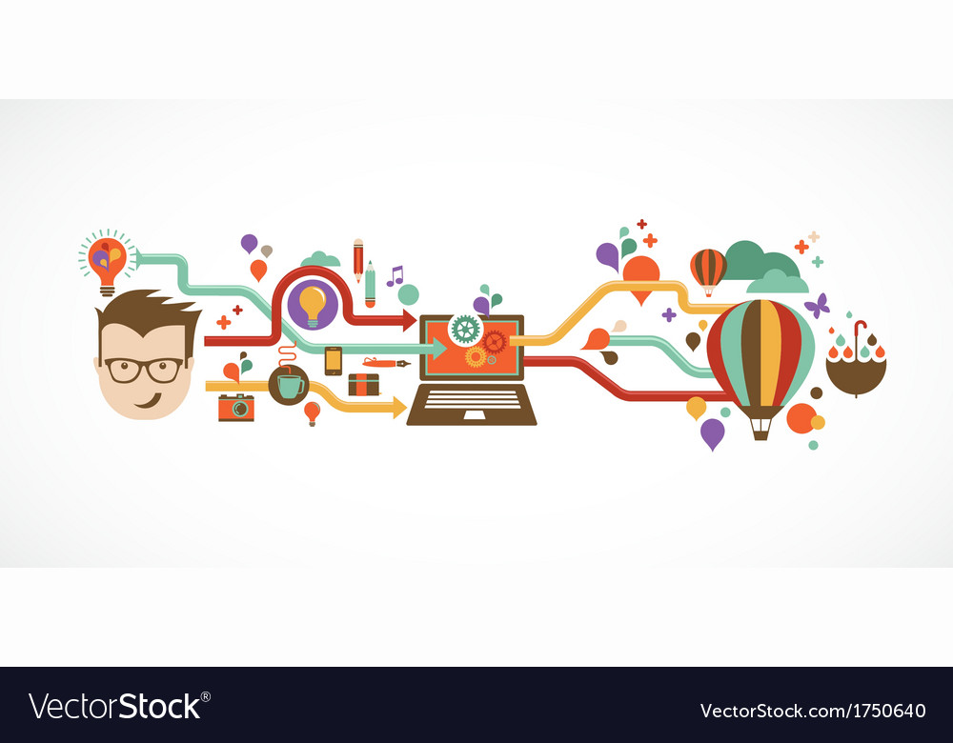

<https://www.vectorstock.com/royalty-free-vector/design-creative-idea-and-innovation-infographic-vector-1750640>

**Fonts**

* open sans condensed [for paragraph]
* vibes [for thought cloud]
* Dosis [speech cloud]

Instagram link

<https://www.instagram.com/rudimentary_alternative/>